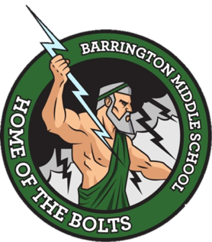

Barrington Middle School
SAC Agenda
September 28, 2022 (Canceled due to Hurricane Ian)
October 26, 2022
Media Center

- Attendance

- Call to Order

- Approval or Correction of Minutes from August 24, 2022

- New Business
- Professional development for teachers on assessment was held on Monday, September 19.
- Statewide assessment calendar
- Update on Barrington data (Ms. Cummings)

- Announcements (for the good of the group)

- Adjournment

